**Step 1:**

Once you have collected your **online registration letter** from reception, log onto patient access: **https://www.patientaccess.com/**

This should be the first screen you see

Click on the “Register online” button in the top right hand corner

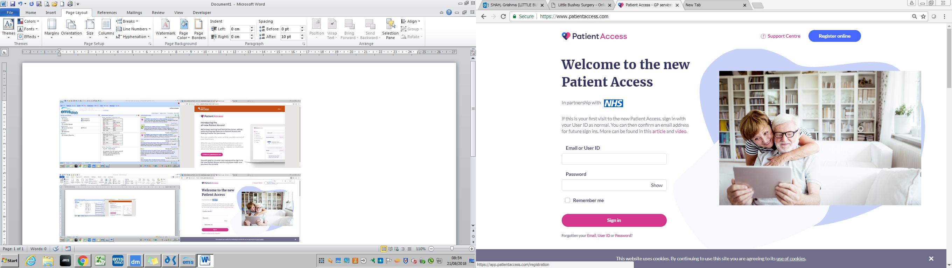

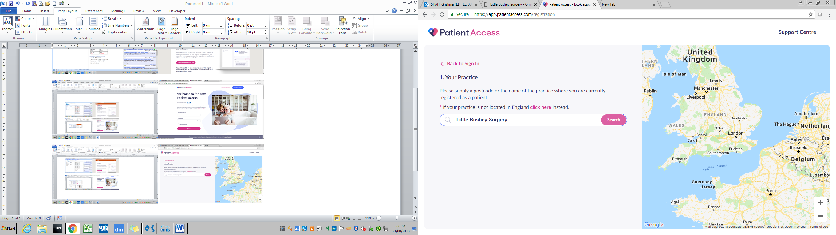

**Step 2:**

Enter Little Bushey Surgery and click search

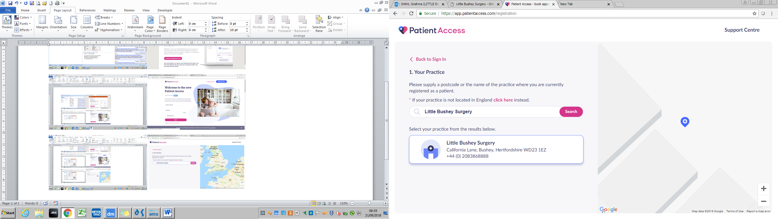

**Step 3:**

Select the practice from the results and click on continue at the bottom of the screen

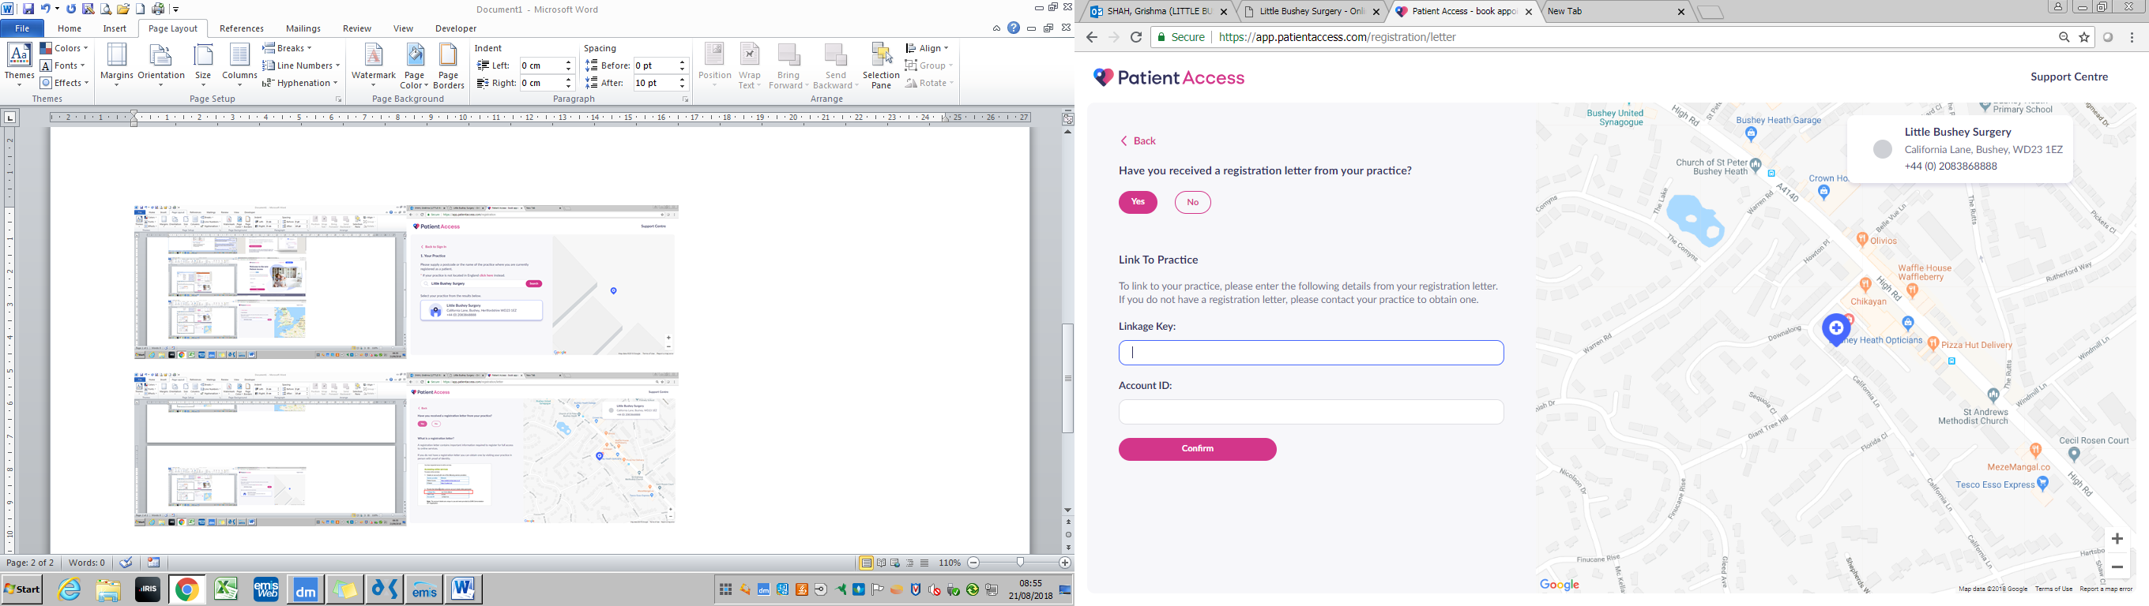

**Step 4:**

This is the section where you will need your Online Access Registration Form

Click on Yes

Then enter the linkage key and Account ID

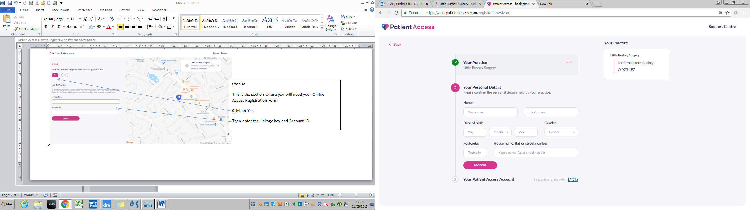

**Step 5:**

Fill in your personal details

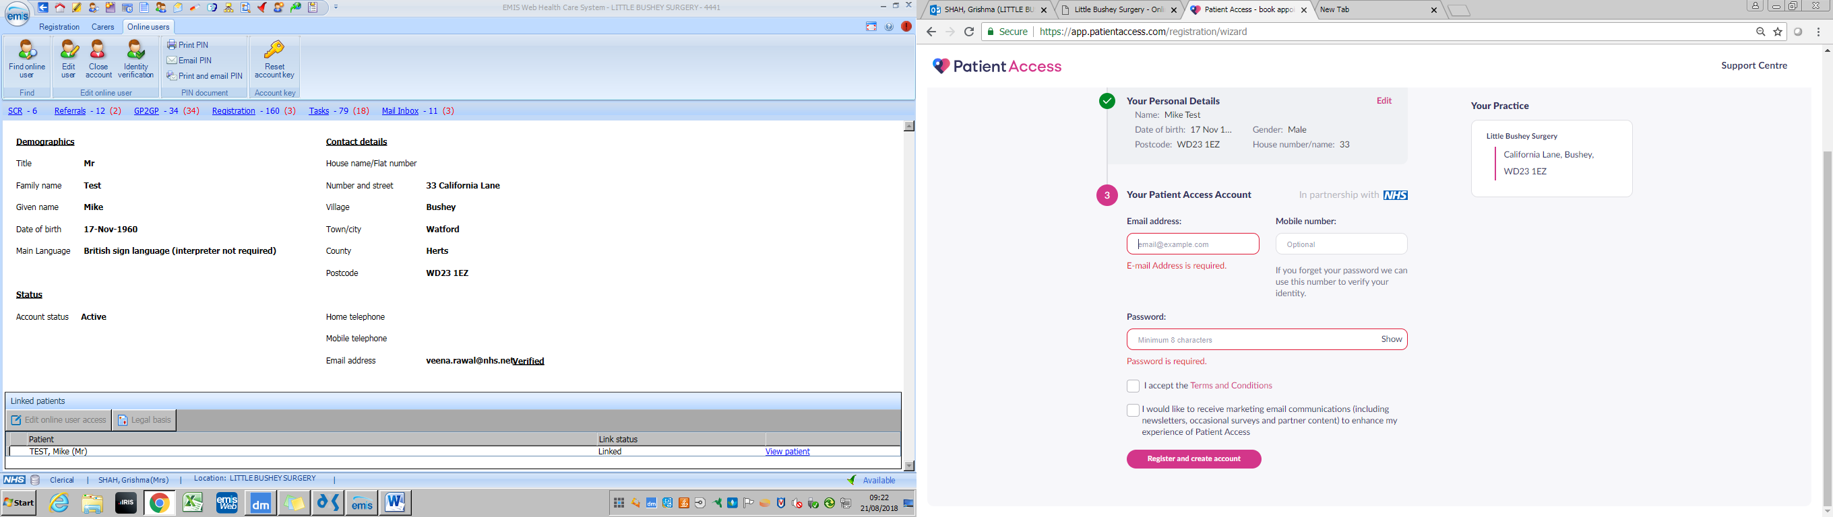

**Step 6:**

Fill in your email address and create a password

Make sure you tick the Terms and Conditions box

Then click on the “register and create account” button at the bottom